LAB DAY 13:

Name: Gopika J Reg No:192324032

1.Prim’s Algorithm:

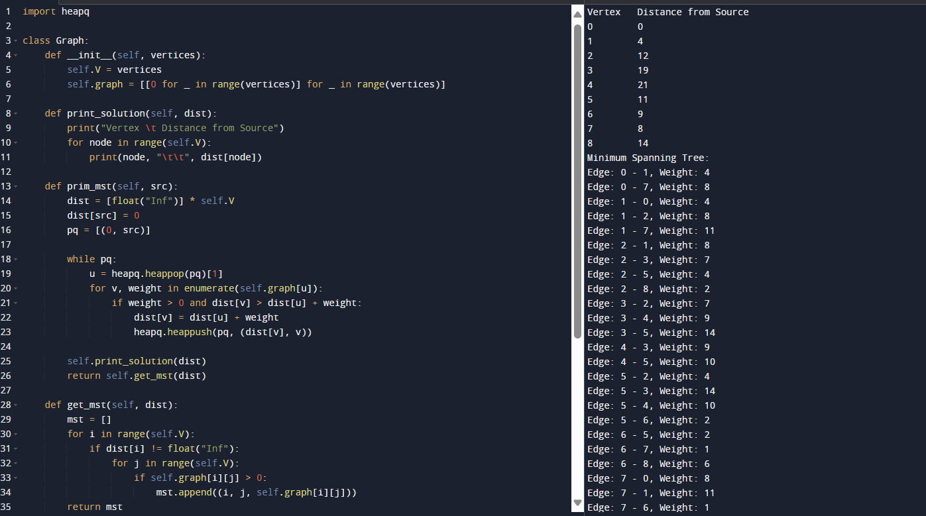

2.N-Queens problem:

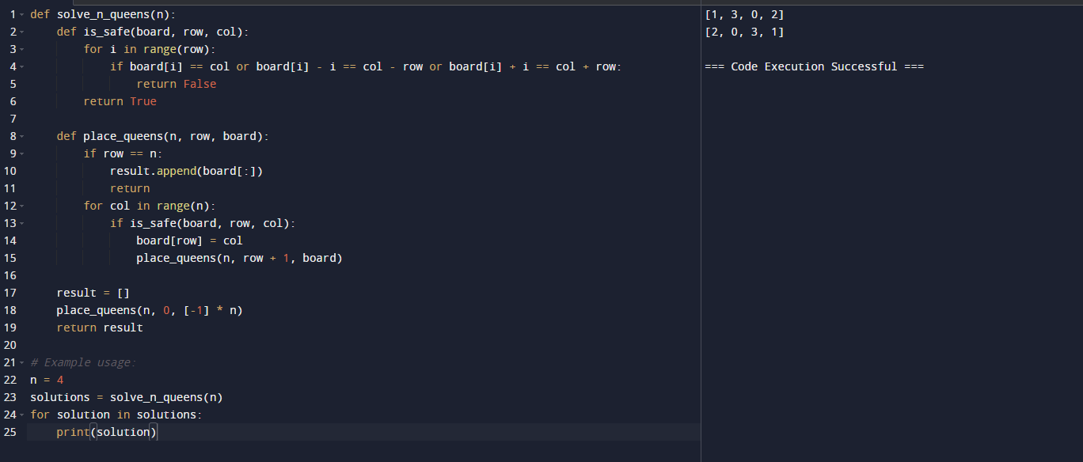

3.Sudoku Solver:

